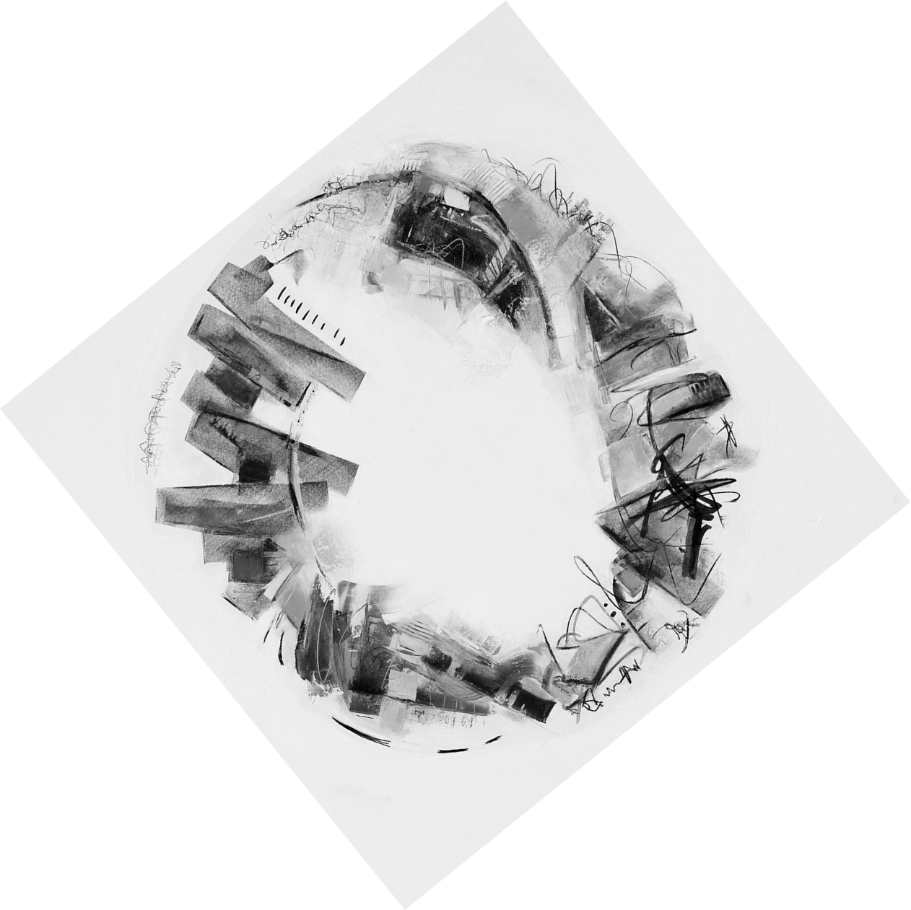

CYNTHIA LEE
SERIES TITLE: “CIRCLING THE SQUARE”
ARTIST STATEMENT
Time seems to move more quickly now. As decades roll by, a sense of my own mortality grows. Climate change, a global pandemic, and our current political unrest add dark notes to daily life. Tipping points are everywhere. I long for simplicity. I crave moments of stillness.
In my paintings, I express this by contrasting complex areas with more open space. But this space is not empty. It holds my thoughts and feelings about impermanence, the role memory plays, the need for us to tell our stories and leave our marks.
I build layers of oil mixed with cold wax to form a history. Circular shapes convey the cyclical nature of life and our human connections. Scribbles suggest language or communication. Rectangles act as mirrors and frames for memories. Images become stories.
I am reminded of a lovely Italian custom of walking around the town plaza late in the afternoon. I want to walk there, together with old and new friends, and with perfect strangers, all of us sharing our stories in the angled sunlight and shadows, finding the joy of connection.

